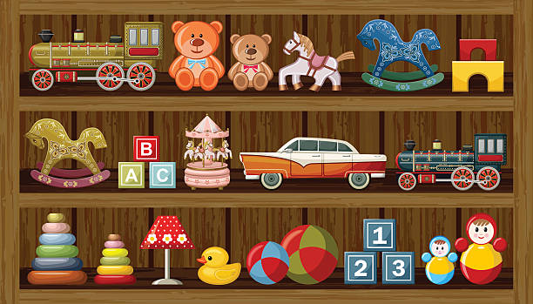
RHE
Keeping Safe
Emergencies

Science
Trees
Everyday materials

Computing
Technology around us

Art
Spirals

PE
Gymnastics
Fundamental skills

RE
Hinduism
Maths:
Numbers to 100
Comparison of quantities and part-whole relationships
Numbers 0-5
Mastering Number
Phonics:
Recap set 1 sounds
Learn set 2 & 3
Writing:
Handwriting – letter formation
Handwriting – letter size
Capital letters
Full stops
Finger spaces
Introduce adjectives
Introduce exclamation marks
Setting / character description
Simple verb suffixes
Personal pronouns
Past tense
Reading:
Lost in the Toy Museum – David Lucus
Stuck! – Oliver Jeffers
Stanley’s Stick – John Hegley
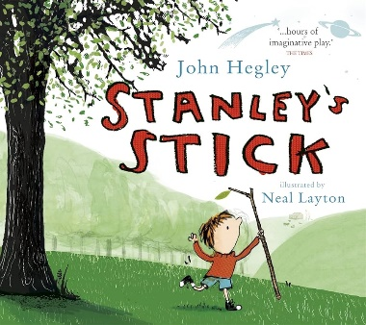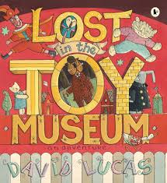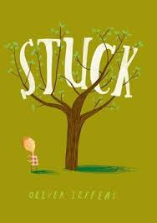
Stunning Start: Bring your favourite toy
Marvellous Middle: Museum visit
Fabulous Finish:
Robins
Autumn Term
Toys Through Time

