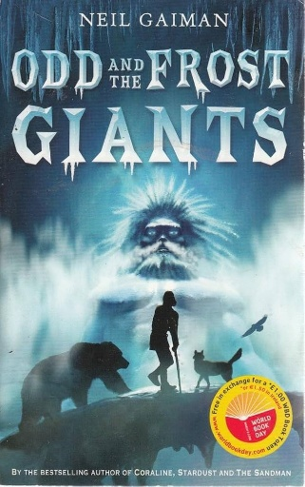
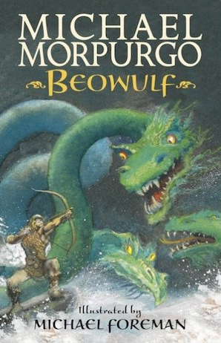

Reading:
Beowulf – Michael Morgurgo
Odd and the Frost Giant – Neil Gaiman
Maths:
Short multiplication and division
Use the formal written method to multiply and divide a 3 digit number by a 1 digit number.
Maths:
Negative numbers
Place negative numbers on a number line in various contexts including graphs, coordinates and temperature.
Writing:
- Brackets, dashes or commas to indicate parenthesis
- Use of commas to clarify meaning or avoid ambiguity
- How hyphens can be used to avoid ambiguity
-Relative clauses
-Commas in a list
-Prepositions
-Fronted adverbials

Stunning Start: Classroom Invasion
Marvellous Middle: Viking Long Boat Art
Fabulous Finish: Museum Trip

RHE
Online and digital Media

Science
Materials

History
Vikings in Britain

Computing
Systems and networks

DT
Textiles

PE
Gymnastics
Handball

RE
Hinduism
Kingfishers
Autumn 2
Vikings: Beyond the Myths

