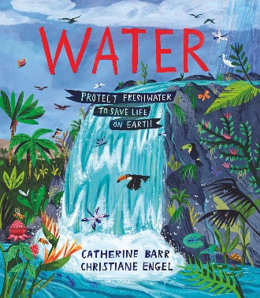
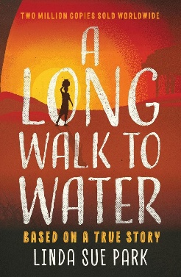
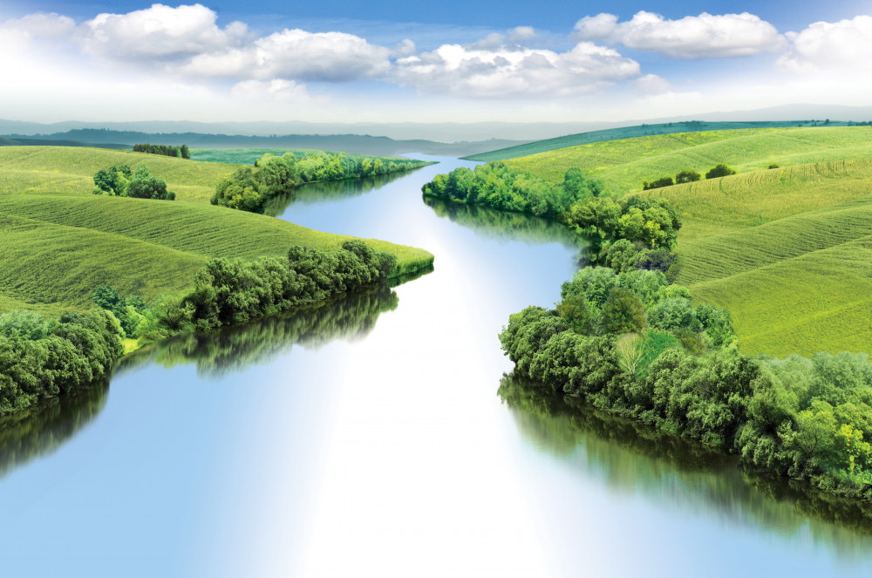
Reading:
A Long Walk to Water – Linda Sue Park
Water – Catherine Barr
Maths:
Money
Convert between pounds and pence, calculating change and total price.
Stunning Start: Big picture – our class river
Marvellous Middle: River Trip
Fabulous Finish: Plastic River Art
RHE
Online and digital Media

Science
Materials

Geography
Rivers

Computing
Systems and networks

Art
Typography

PE
Gymnastics
Basketball

RE
Hinduism
Kingfishers
Autumn 1
The wonderful World of Rivers
Maths:
Decimal fractions
Identify, compare and order tenths, hundredths and thousandths as decimals, percentages and fractions.
Writing:
-Synonyms and antonyms
-Modal verbs
-Active and passive voice
-Cohesion within a paragraph
-Adverbials of time, place and manner
-Intentional repetition of a word or phrase
-Simple, compound and com plex sentences
-Expanded noun phrases
-Modifiers
-Plural and possessive
-Contractions

