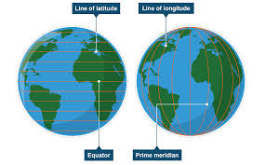
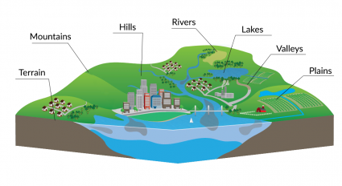
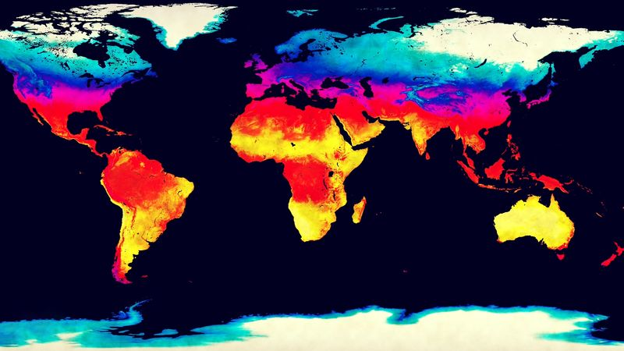
Spies around the world…
Year 5 Autumn 2
Key Vocabulary:
latitude, longitude, equator, hemispheres, tropics, prime, meridian, time zones, topography, region, physical, human, county, city, country, continent, climate
Key Questions:
How do physical features like mountains, rivers, and climate influence the locations and development of major cities around the world?
What are the key physical and human characteristics that distinguish different regions of the UK, and how do they influence the economy and daily life?
How do the positions of the Equator, Prime Meridian, and hemispheres help us understand global time zones and seasons?
What I know:
Recognise a map as a representation of the world.
Locate the seven continents and five oceans.
Name, locate, and identify the four countries of the United Kingdom and their capital cities.
Understand simple compass directions (north, south, east, west).
Identify and name key physical features such as mountains, rivers, forests, valleys, beaches, and seas.
Identify and name key human features such as towns, cities, villages, roads, bridges, and shops.

What I will learn:
Locate countries around the world using maps, exploring their environmental regions, key physical and human features, countries, and major cities.
Name and locate UK counties and cities, its geographical regions, key human and physical features, and topography (hills, mountains, coasts, rivers.)
Identify the position and significance of latitude, longitude, the Equator, hemispheres, Tropics of Cancer and Capricorn, Arctic and Antarctic Circles, the Prime Meridian, and time zones (including day and night).
Study and compare the human and physical geography of a region in the UK, a European country, and North or South America.

