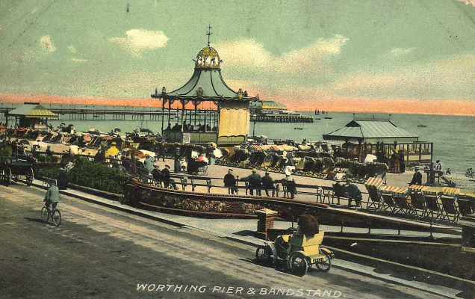


Sunny Worthing

Geography vocabulary
United Kingdom, England, West Sussex, South East, town, county, scale, distance, direction, sea, shoreline, beach, channel, river, downland, hills, erosion, environment, population, tourism, commercial, farming, residential, pier, promenade.
What I am going to learn…
Locate Worthing on a map of the UK and describe its position using key geographical vocabulary.
Describe the physical and human features of Worthing using fieldwork, observations and maps.
Explain how Worthing has changed over time and how land use varies across the town.
Compare Worthing to a rural town in England and a major city.

What I already know...
The four countries of the United Kingdom and their capital cities.
Location of the UK on a World map.
The continents and oceans of the world. Some understanding of the UK’s seasons and weather patterns.
Use simple maps and atlases.
Compass directions

Year 3 Autumn Term

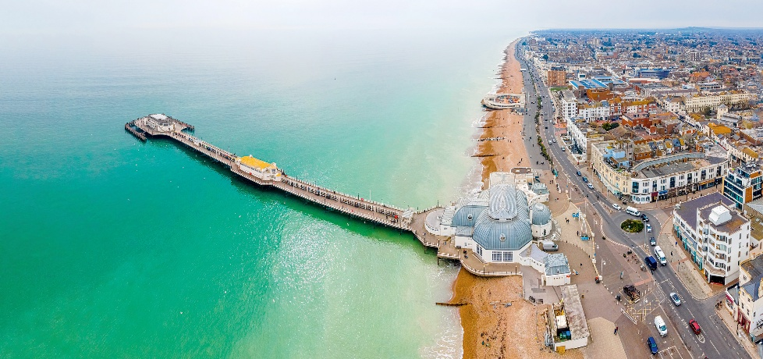

Key Questions I will be able to answer…
Why does the coastline change? What does Worthing offer tourists? How does Worthing compare to other towns and cities?
How does erosion happen? How has the landscape changed?

