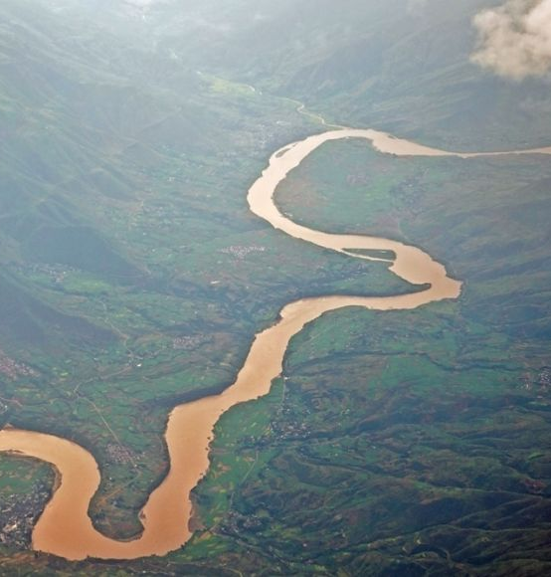
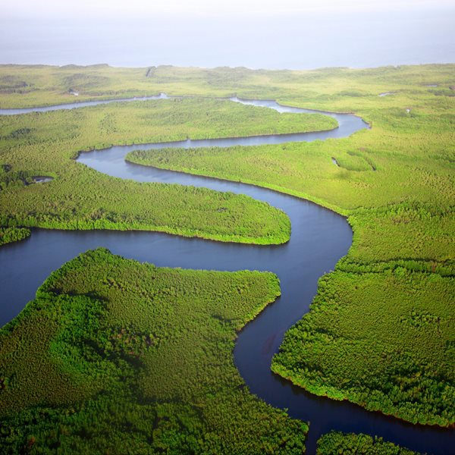
Rivers

Vocabulary
Erosion, transport, deposit, river, delta, stream, source, mouth, sediment, pebble, sand, water estuaries, pollution, meander, Earth

What I am going to learn…
Understand the Water Cycle.
How rivers erode, transport and deposit materials.
Why rivers are important to animals and people.
Investigate a river in detail.
River pollution and the impact on the environment.
Conduct and independent geographical Enquiry.
What I already know...
That water exists in different forms (solid ice, liquid water, gas/steam).
That weather brings rain, snow, sun, and clouds.
That rivers are moving bodies of water which flow downhill into the sea.
That fast water can wash things away (mud, sticks, leaves).
How to locate a river on a map.

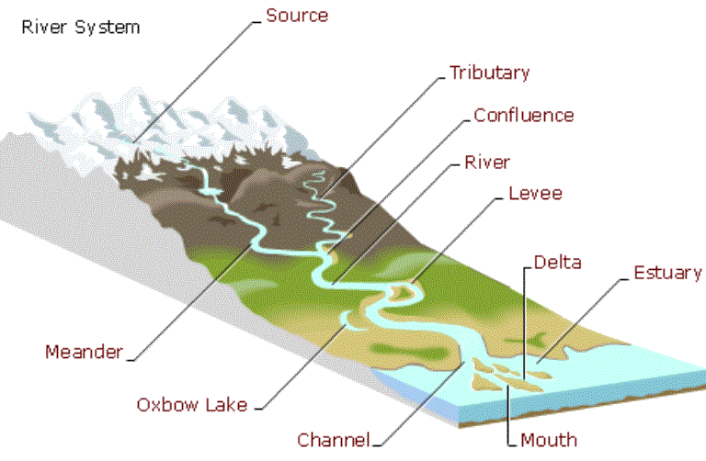

Key Questions I will be able to answer…
Where does the water in a river come from? How does water move between the sea, land, and sky?
How do rivers change the landscape? What happens to rocks and soil when a river flows over them?
What features can we see along its course (meanders, floodplains, deltas)? What types of pollution can affect a river?

