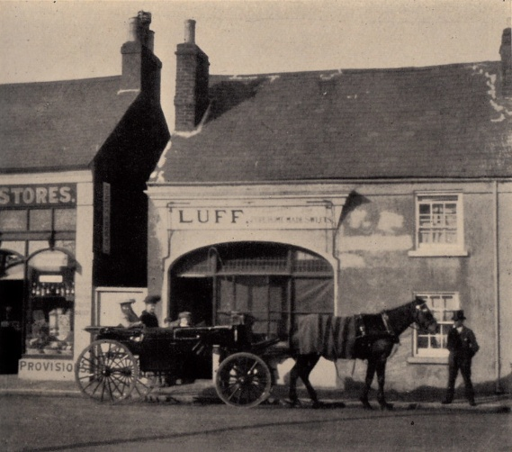
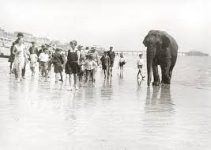

Sunny Worthing

History vocabulary
Timeline, period. Era, decade, post war, modern, seaside resort, coastal town, heritage, fishing village, expansion, invasion, memorial, source, evidence, bias, opinion, fact, interpretation, compare, significance, railway, factory, migration, cottage, terrace, landscape.
What I am going to learn…
Understand that history can be studied through local evidence.
Place key events in Worthing’s history within a broader chronological framework.
Describe how Worthing has changed over time and why.
Use a range of historical sources to ask and answer questions about Worthing’s past.
Explain how national and global events affected local people in Worthing.

What I already know...
Sequence time chronologically.
Understand that some things happened at the same time in different places.
Changes within living memory.
Events beyond living memory.
Romans in Britain.
Vikings and their impact on Britain.

Year 3 Autumn Term

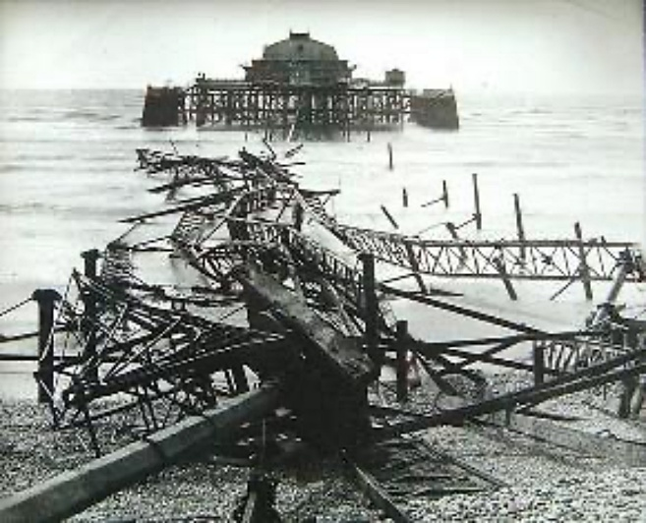

Key Questions I will be able to answer…
What is local history and why should we study it? What clues can we find about the past of our town? What was Worthing like in the past?
How did Worthing become a seaside resort? Why did people start visiting Worthing in the 1800s?

