Properties and changes of materials
Absorbent – the ability of a material to soak up a liquid. | 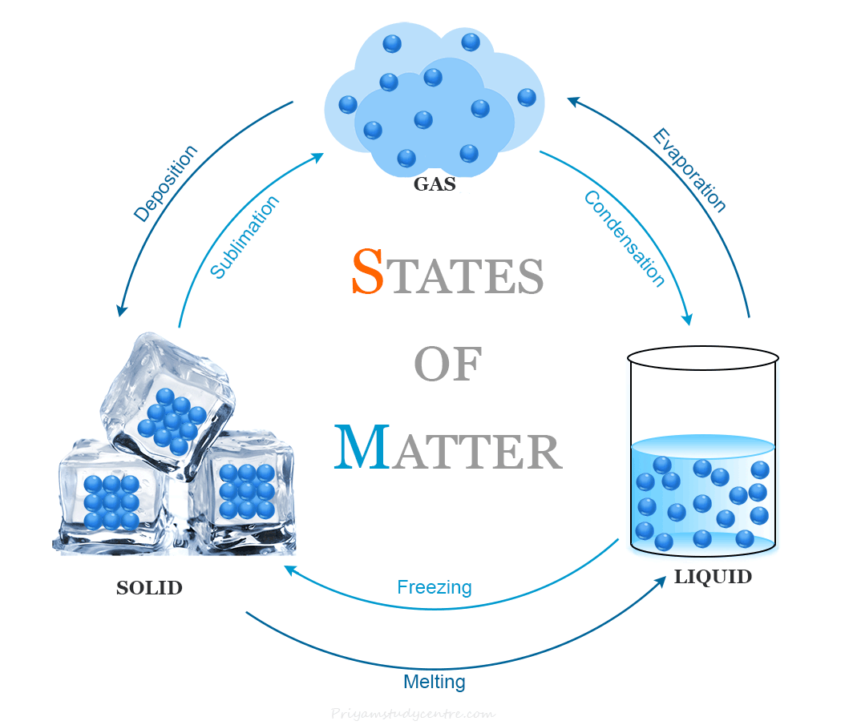Changing state from a solid to a liquid and a gas and back again, is a reversible change. | 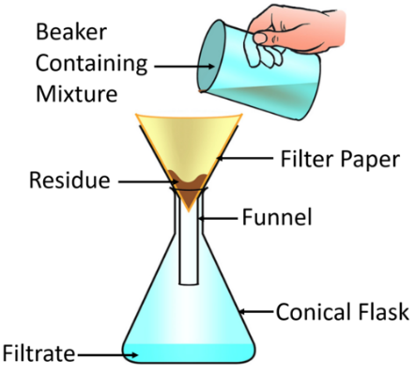  Filtration is when a solid and a liquid are passed through a filter, which only allows the liquid to pass through it.
Elasticity – the ability to return to it’s original shape when force is removed.
Flexible – the ability to bend without breaking.
Insulating – the ability to prevent the loss of heat or the intrusion of sound.
Irreversible change – A change that cannot be undone. |  | 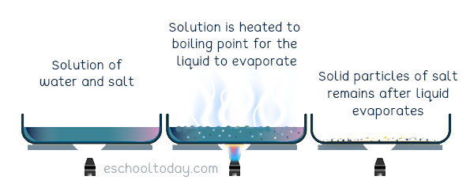  Evaporation is when you apply heat to a solution to turn the liquid into a gas. This leaves behind the solid part of the mixture.
Magnetic – the ability to be attracted to a magnet. | 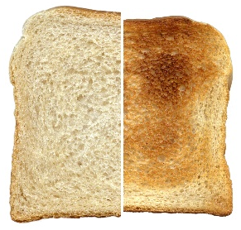  Cooking is an example of an irreversible change. The use of heat has created a permanent chemical change that cannot be undone.
Opaque – Does not let light travel through it.
Permeable – the ability to allow liquid to travel through it.
Soluble – the ability to be dissolved in a liquid. |   Materials are either magnetic or nonmagnetic. Nonmagnetic materials are not metallic BUT not all metals are magnetic. | 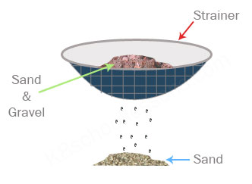  Sieving is the process of separating a dry mixture.
Transparent – allows light to pass and objects to be seen through.
Waterproof – The ability to repel liquids.

