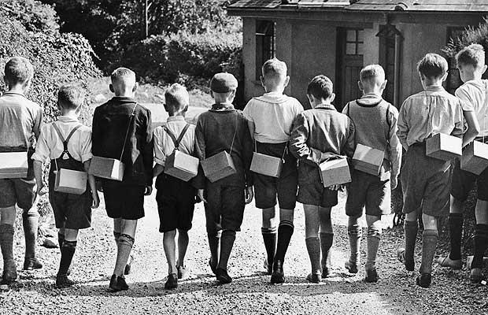
RHE
- Media Influences: masculinity and femineity
- Pressure to share and dare
- Body privacy
Music
- Glockenspiels
- Singing
DT
- Food – tasting, designing, cooking and evaluating scones
Science
- Light – how it travels, shadows, reflection, refraction and the eye.
- Electricity – building, drawing circuits, conductors, insulators and an investigation
Maths
- Place Value, Negative Numbers and Rounding
- Addition, Subtraction, Long Multiplication and Short Division
- Arithmetic and Times Tables
Writing
- Writing to entertain – setting description of the outbreak of war in Germany
- Writing to inform – formal speech announcing the declaration of war in role as the Prime Minister of the UK
- Writing to reflect – poem about the Windrush Generation
History
- World War 2 – timeline of the outbreak, declaration of war, evacuation, the blackout, Battle of Britain, The Few, VE day
- The Taste of Change from 1945-2000 – immigration and the Windrush Generation, multicultural and ultra-process influences of British food
Reading
- Reading two class novels:
- Rose Blanche by Roberto Innocenti
- Letters From The Lighthouse by Emma Carroll
- Practise the reading skills of retrieval, using the text to prove an idea and prediction.

Art
- Using charcoal and pastels inspired by the artist and sculpture Henry Moore
RE
- Islam
Computing
- Communication
- Sensing
PE
- Netball, Gymnastics, Yoga
We’ll Meet Again
and
The Taste of Change
Stunning Start
Acting in role as an Evacuee child being evacuated

Marvellous Middle
VE day celebration and Tea Party

Fabulous Finish
Scone Tasting

This Photo by Unknown Author is licensed under CC BY-SA

