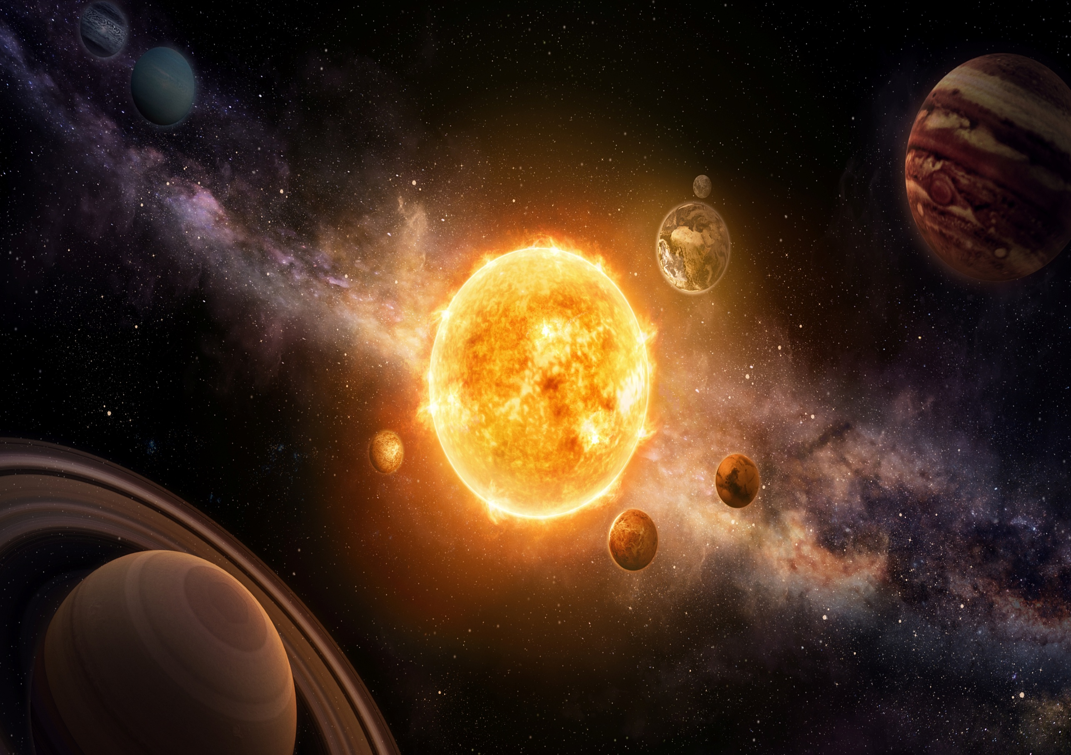
Writing:
-Question tags
-Semi-colon, colon and dash to mark the boundary between independent clauses
- degrees of possibility using adverbs [perhaps, surely]
-Subjunctive forms
- formal language
-Adverbials such as: on the other hand, in contrast, or as a consequence
-Active and passive voice
- Brackets, dashes or commas to indicate parenthesis
-Use of commas to clarify meaning or avoid ambiguity
-Standard English
-inverted commas

Stunning Start: Planetarium Visit
Marvellous Middle: Alien Slime
Fabulous Finish: Ping Pong Solar System
RHE
Drugs and usage
Science
Space
Computing
Databases
History
The history of space travel
Design and Technology
Moon Buggies
PE
Fitness
Football
RE
Christianity - Easter

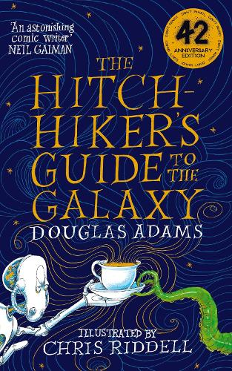
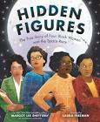
Maths:
Apply the skill to converting measures including grams and kilograms.

Maths:
Multiplying and dividing by decimal fractions including 10, 100 and 1000.
Reading:
The Hitchhiker’s Guide to the Galaxy – Douglas Adams
Hidden figures – Margot Lee Shetterly
Kingfishers
Spring 2
Don’t Panic – A Year 5 Guide to the Galaxy

