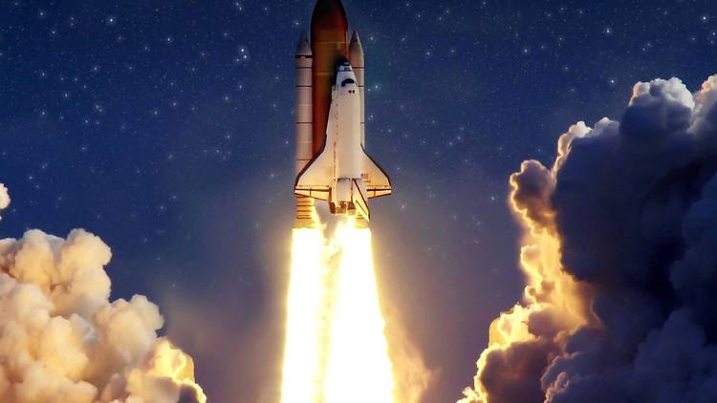
Writing:
-Layout devices
-colon to introduce a list
-bullet points
-semicolon within lists
-Subjunctive form
-Cohesion within a paragraph
-Modal verbs
-Adverbials such as: on the other hand, in contrast, or as a consequence
-adverbials of time
-progressive verbs
-Relative clauses

Stunning Start: Bottle rockets
Marvellous Middle: Astronaut pudding
Fabulous Finish: Mod-roc aliens
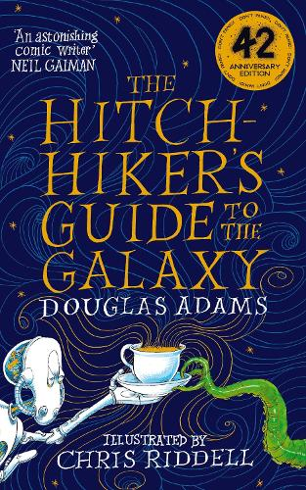
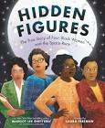
Maths:
Pupils should then learn that the area of a rectangle can be calculated by multiplying the
length by the width.
Reading:
The Hitchhiker’s Guide to the Galaxy – Douglas Adams
Hidden figures – Margot Lee Shetterly
RHE
Drugs and usage

Science
Forces

Computing
Coding with crumble kits

Art
Monotypes

PE
Dance
Dodgeball

RE
Hinduism
Kingfishers
Spring 1
Don’t Panic – A Year 5 Guide to the Galaxy
Maths:
Compare areas and calculate the area of rectangles (including squares) using standard
units.

