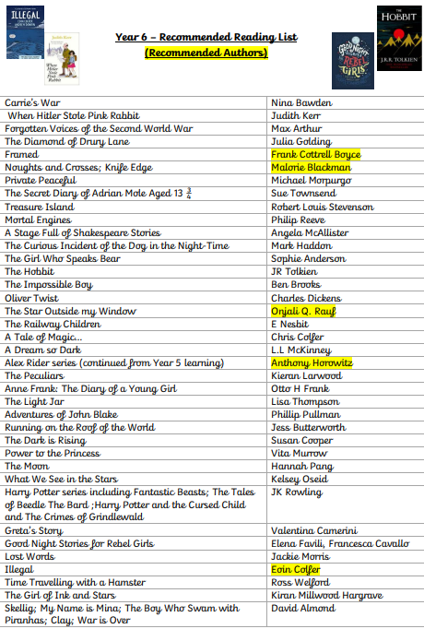

Websites with recommended reading lists:

**School Reading List**

<https://schoolreadinglist.co.uk/reading-lists-for-ks2-school-pupils/suggested-reading-list-for-year-6-pupils-ks2-age-10-11/>

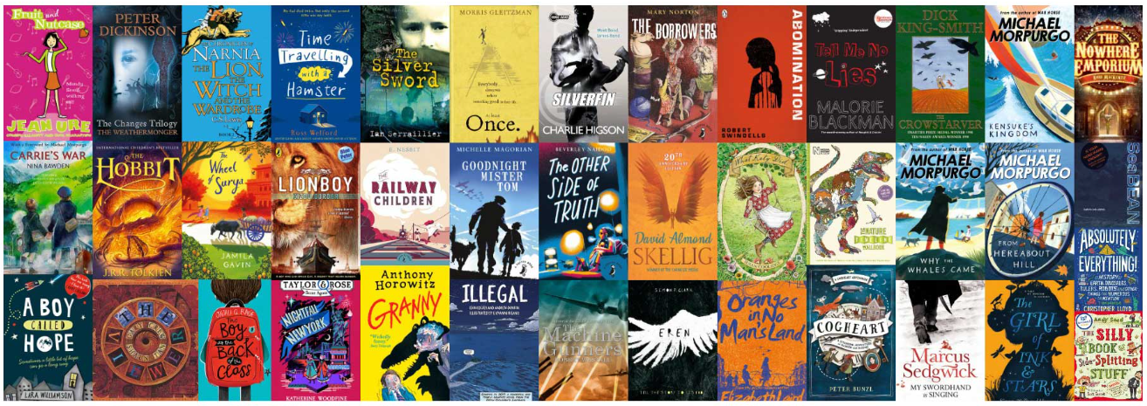

**The Reader Teacher**

<https://www.thereaderteacher.com/upper-ks2>

**Books for Topics**

<https://www.booksfortopics.com/booklists/recommended-reads/year-6/>