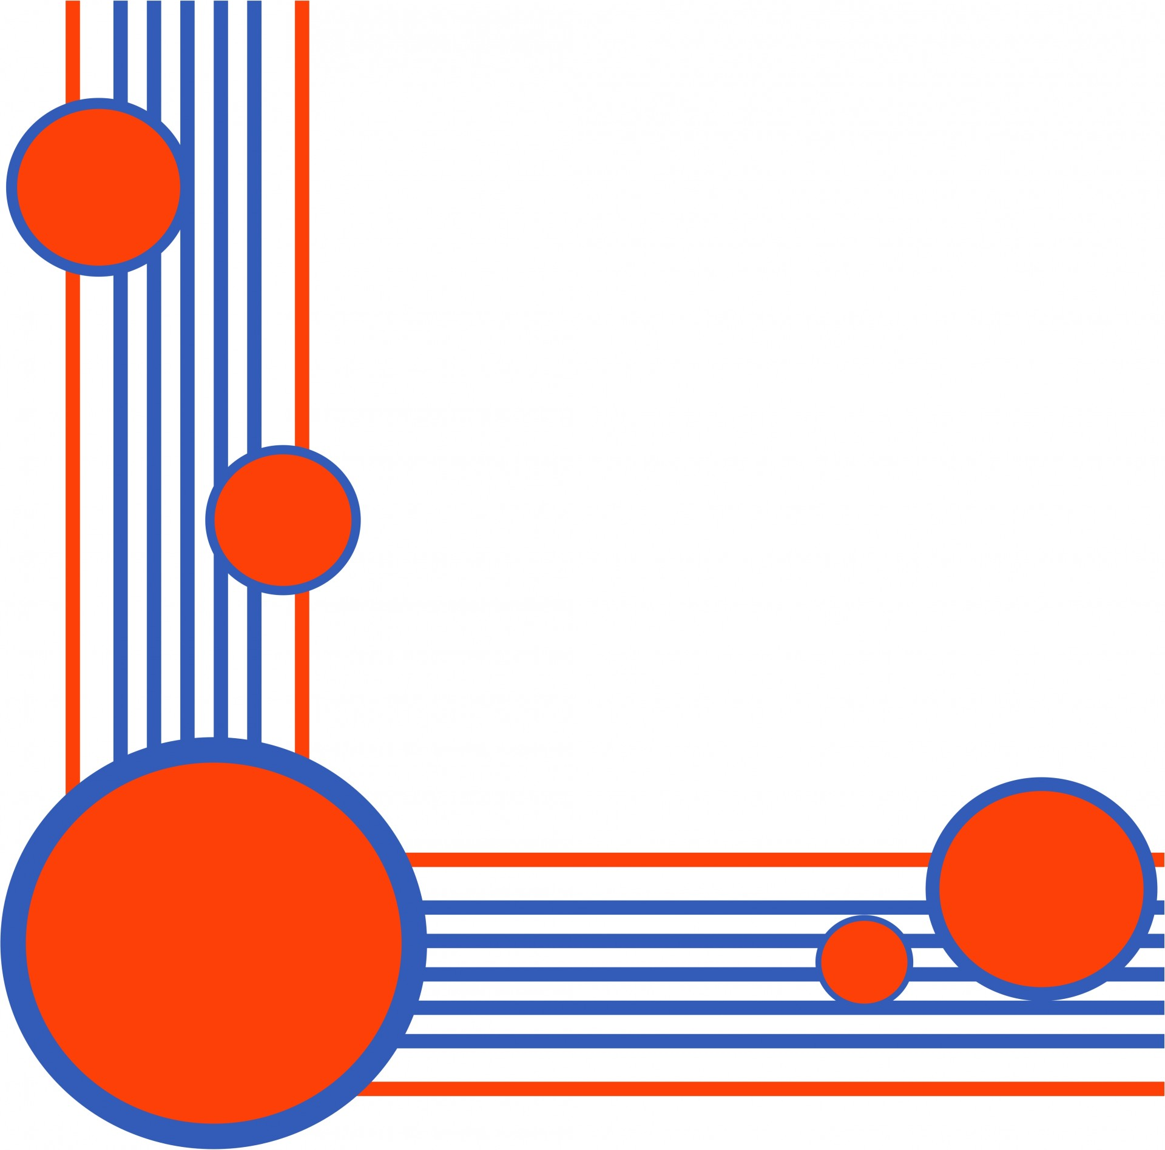

* When you leave the classroom make sure you turn the lights and the board off.
* If you can please turn the lights onto the eco setting if not do eco+max.
* If the ipads are charged fully please do not keep them on charge
* If ipads are not in use please power them off. 